Photo Standalone 16—No Title
Courier (1950–1964); Mar 10, 1951; ProQuest Historical Newspapers: Pittsburgh Courier
pg. 19
Photo Standalone 16—No Title
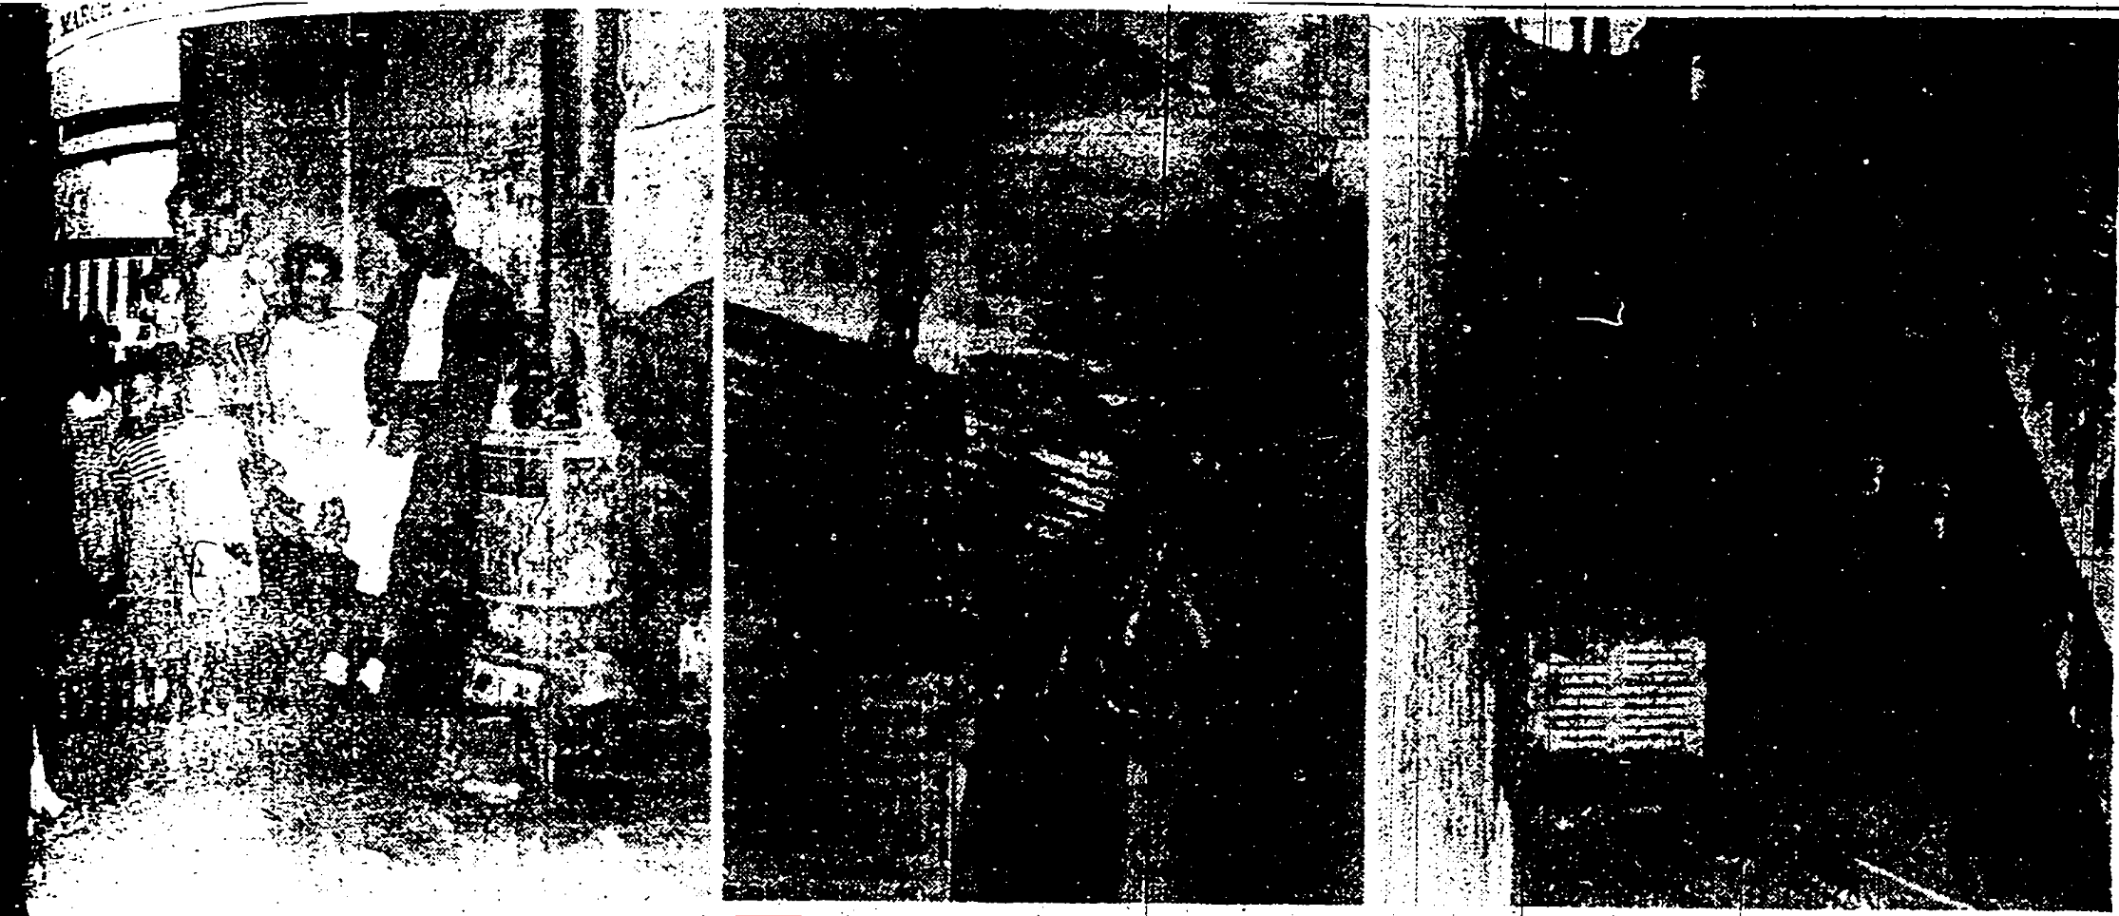
Need Home—*illegible text* One family is that of Mrs. Lillie Copeland, who has five children under 13 years of age, living there with her. The other family is that of Mrs. Copeland’s daughter, Mrs. Lucille Rowe, who has eight children living with her and whose ages range from 11 years down to less than one year. The two women and thirteen children are all living in one room and under the most deplorable conditions. Left to right (1) some of the members of the families, who were at home at the time, post for The Courier photographer. (Mrs. Copeland is shown reclining on a makeshift bed on a trunk, which has been her sick bed for the past three months that she has been ill.” (2) A portion of the ceiling which is unsafe and hardly vermin-proof, and (3) in the right photo can be seen the one oil lantern which serves in lieu of electric lighting, hanging over the stairway. Not too much illumination is offered, especially at night, making passage up and down the stairs a safety hazard. -Harris Photo.
Reproduced with permission of the copyright owner. Further reproduction prohibited without permission.

